GitLab and deploy ML on GCP
When we have multiple module
Must have __init__.py in each folder
Run the code locally
uv run python -m src.data_processing

or
(on powershell)
$env:PYTHONPATH = (Get-Location)
uv run python src/data_processing.py
push repo on gitlab and set container as AKS
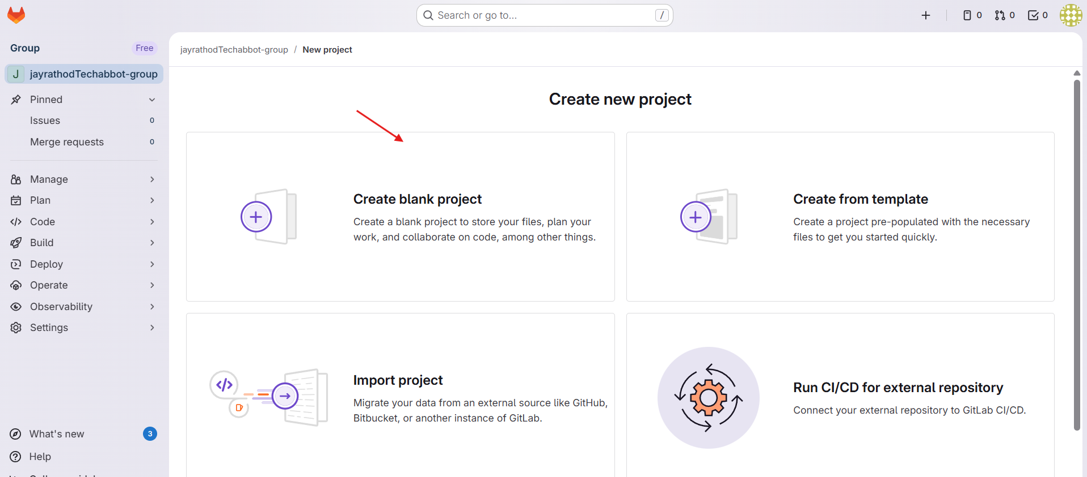
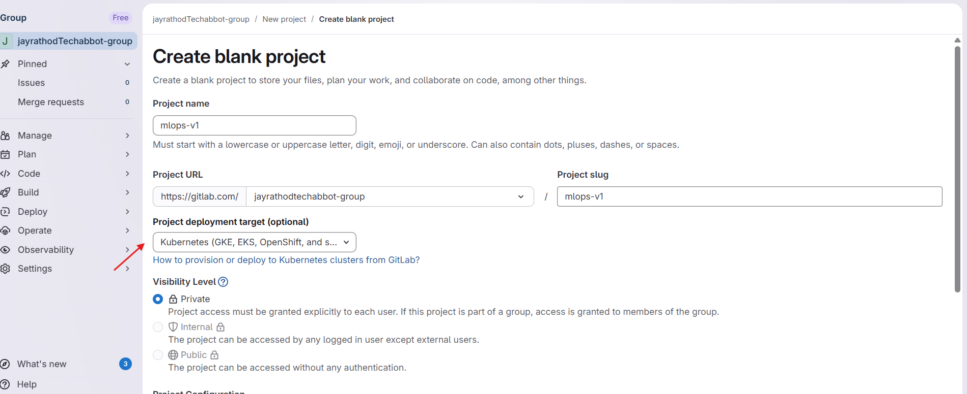
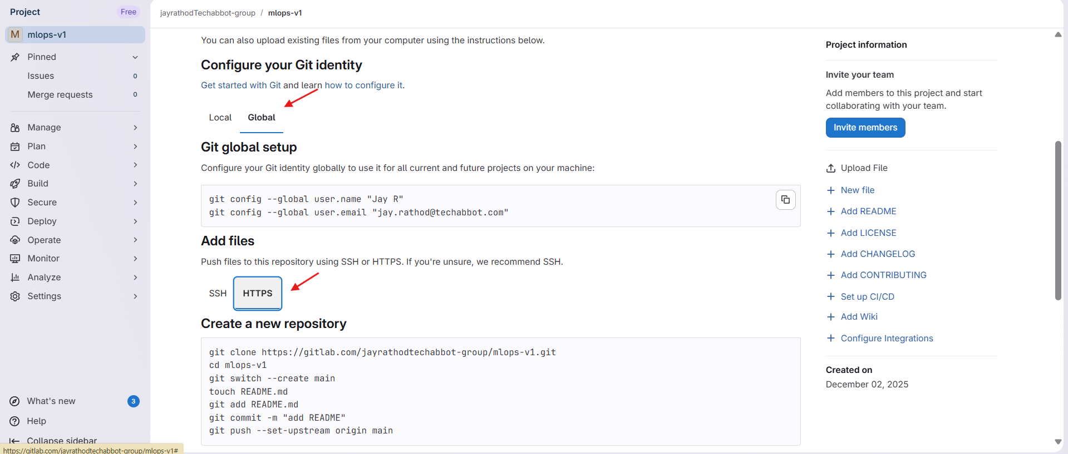
Setup GCP
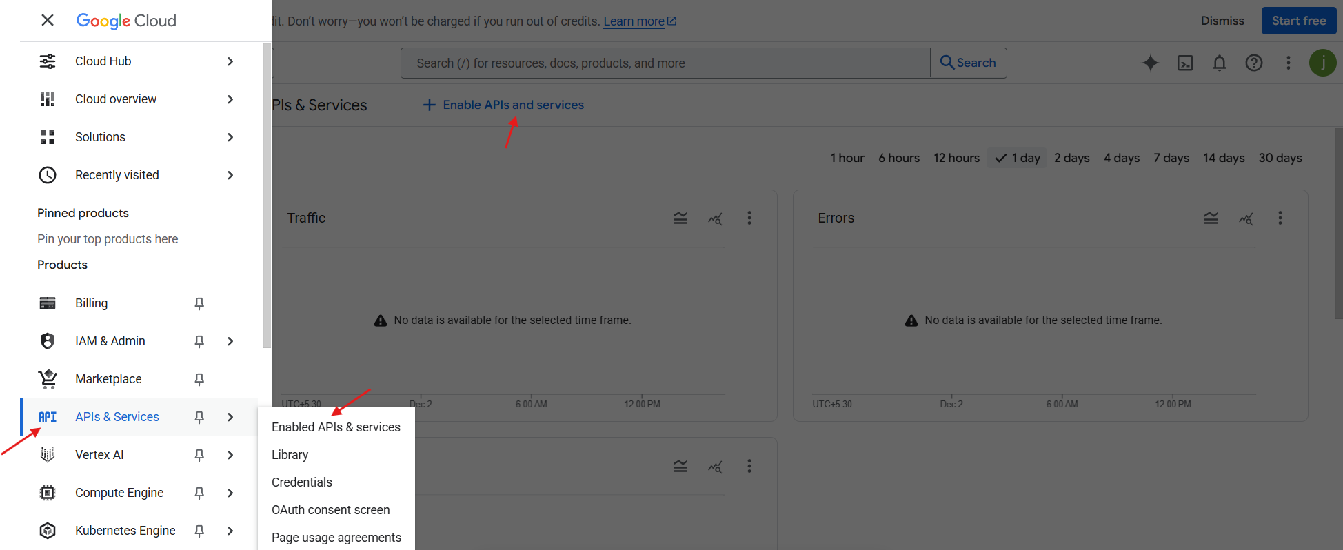
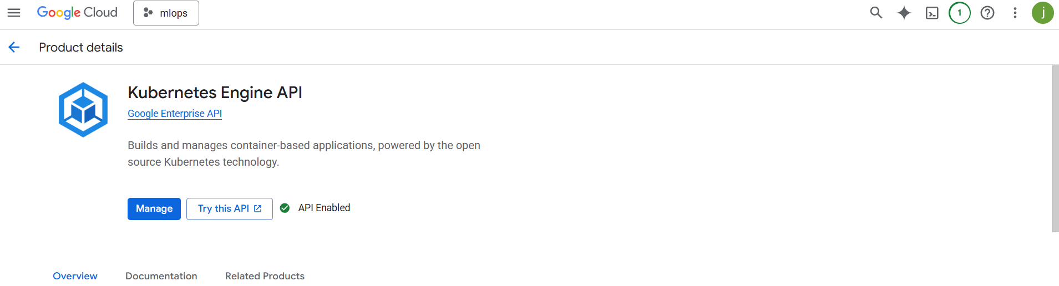
Enabled :
- Google Container Registry API
- Compute Engine API
- Identity and Access Management (IAM) API
- Cloud Build API
- Cloud Storage
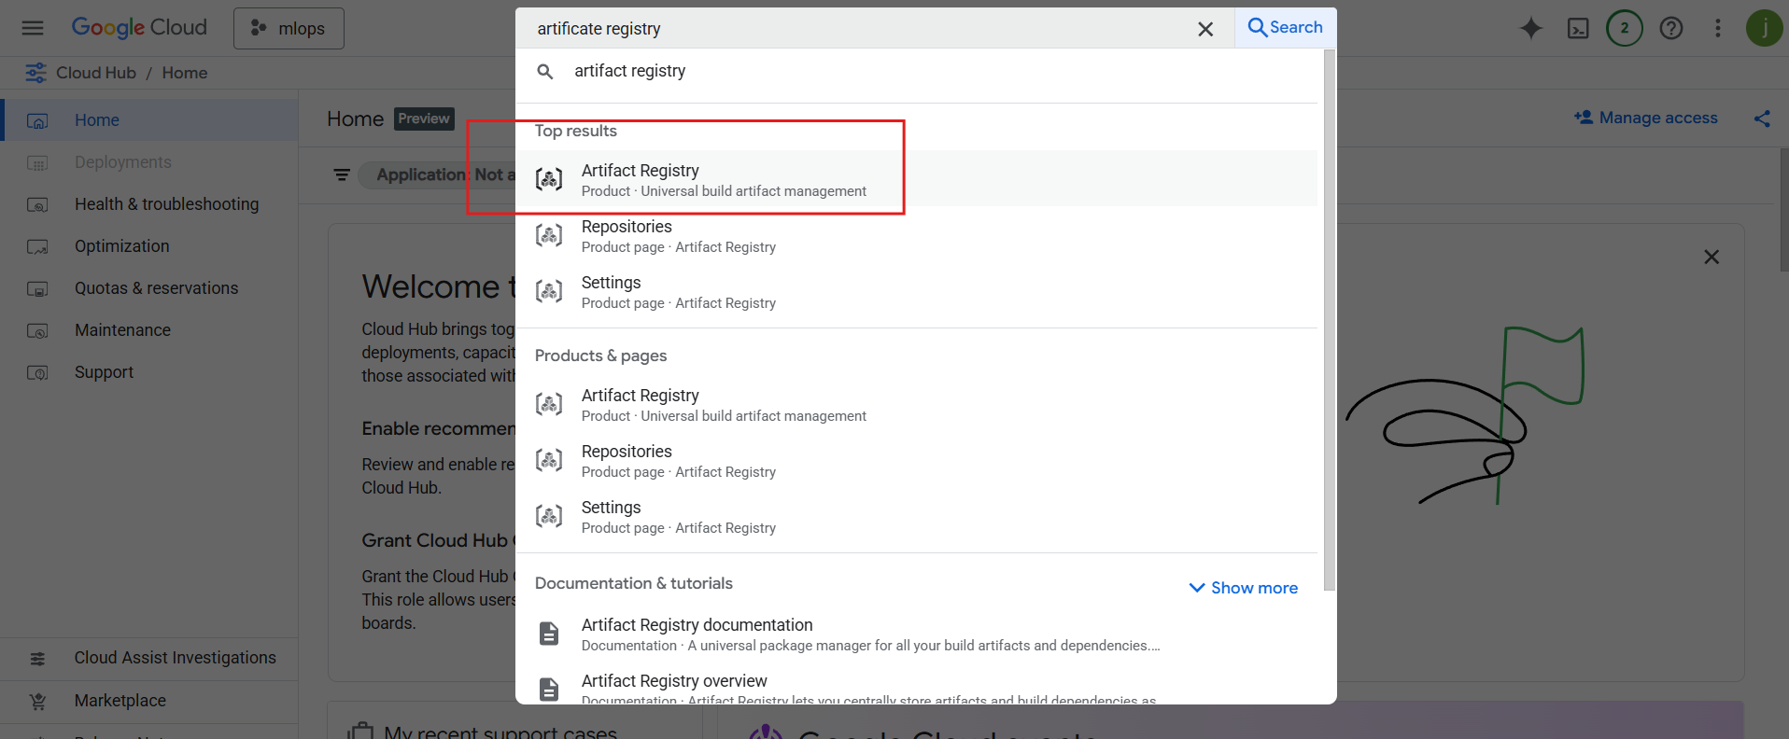
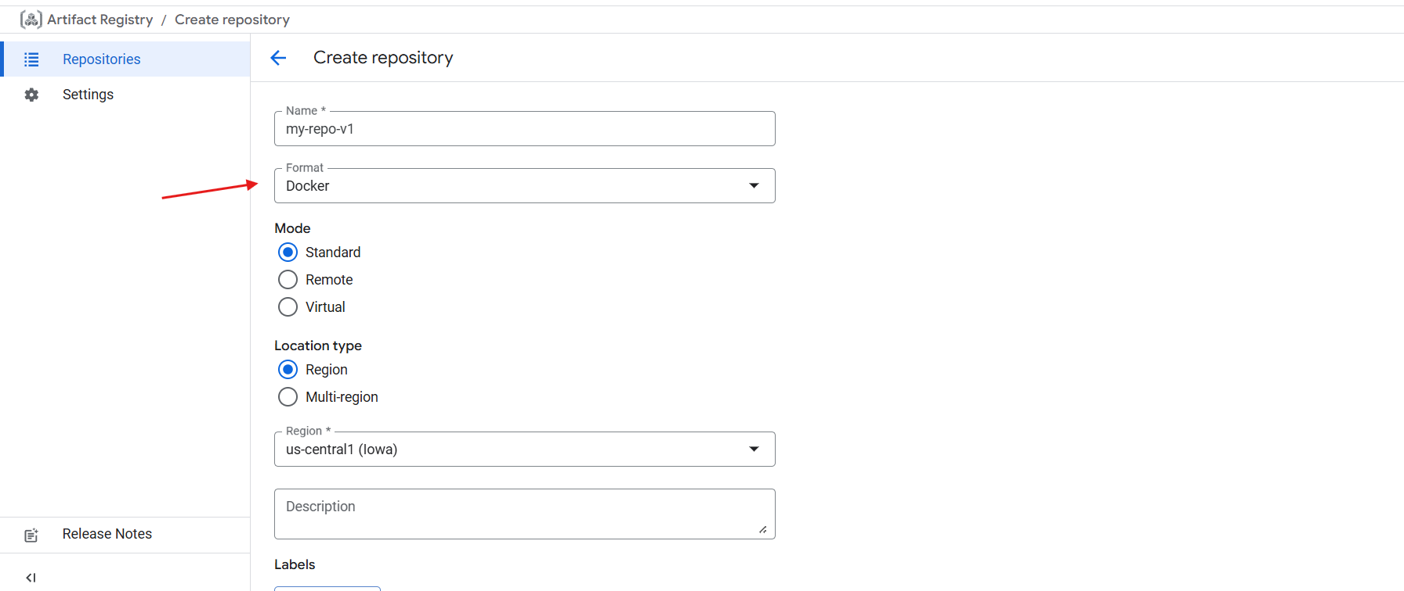

Create a service account
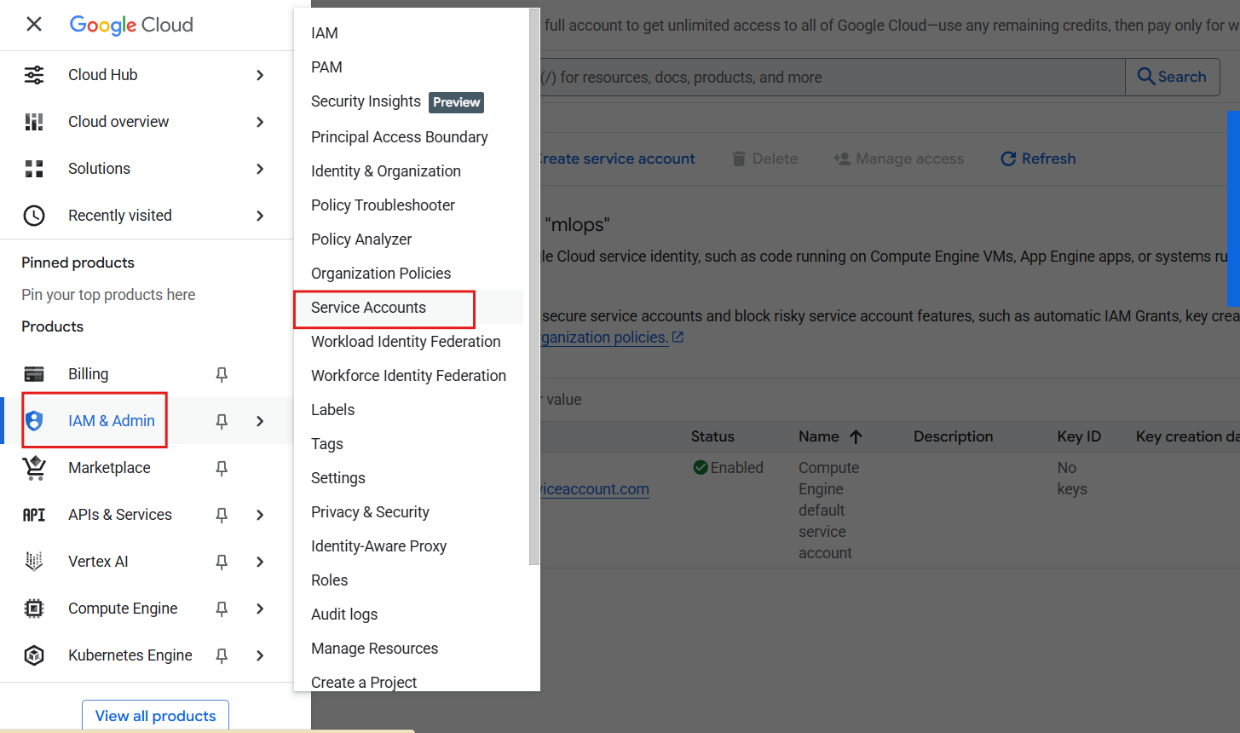
Create a service account
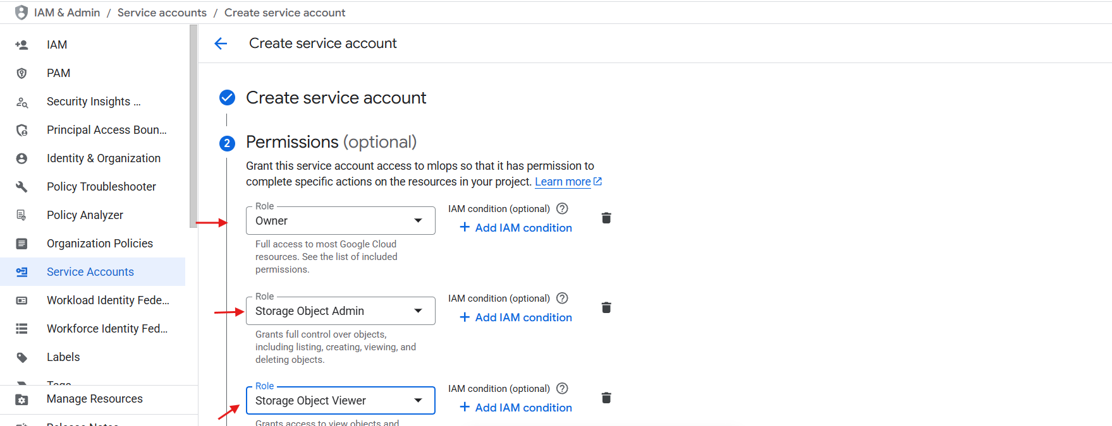
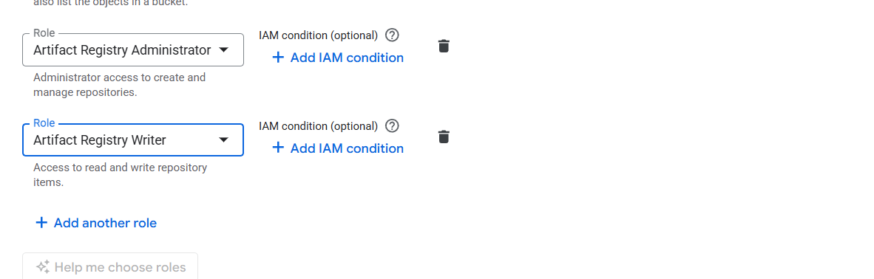
Continue > Done

Download private key of service account
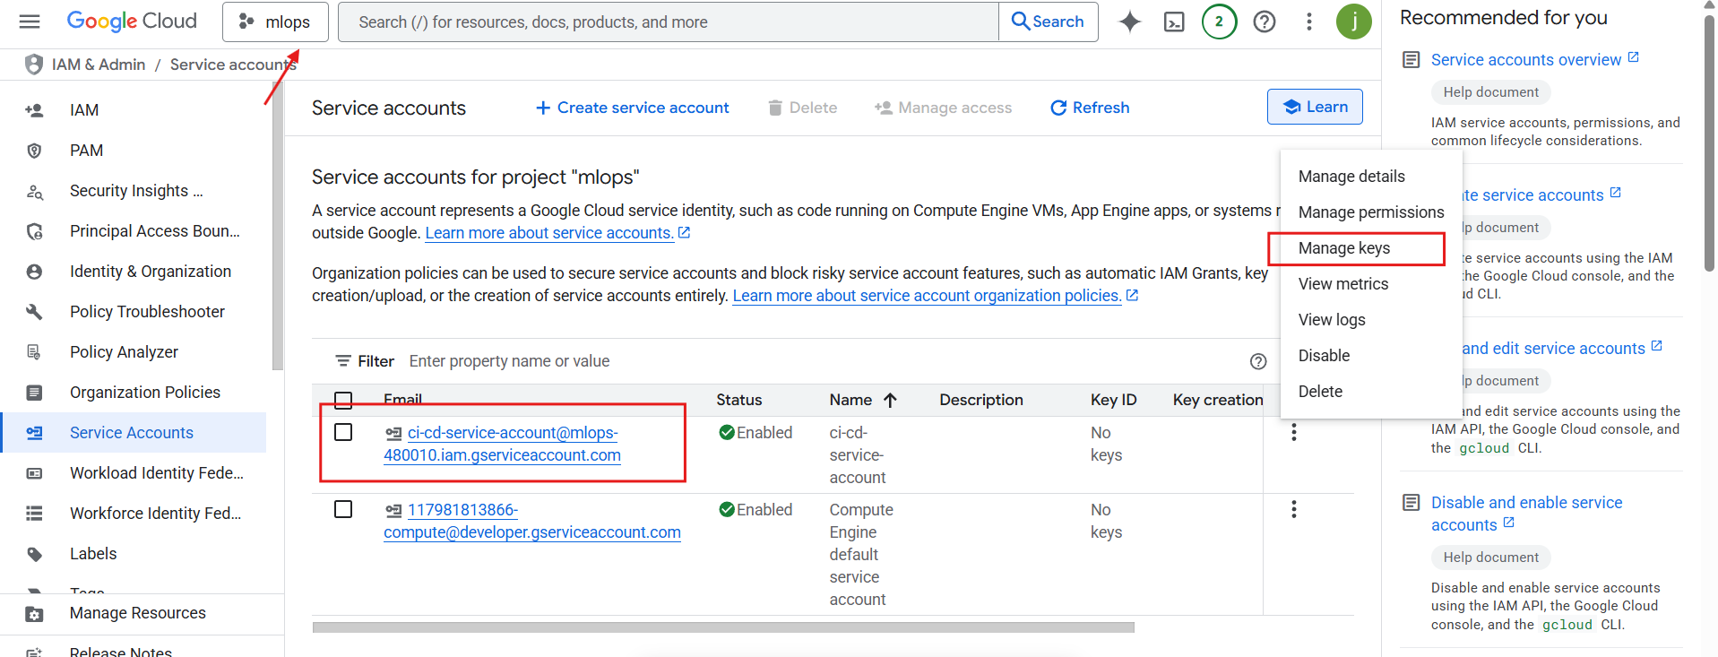
Add key > create a new key > JSON
Put in the root directory of vs code
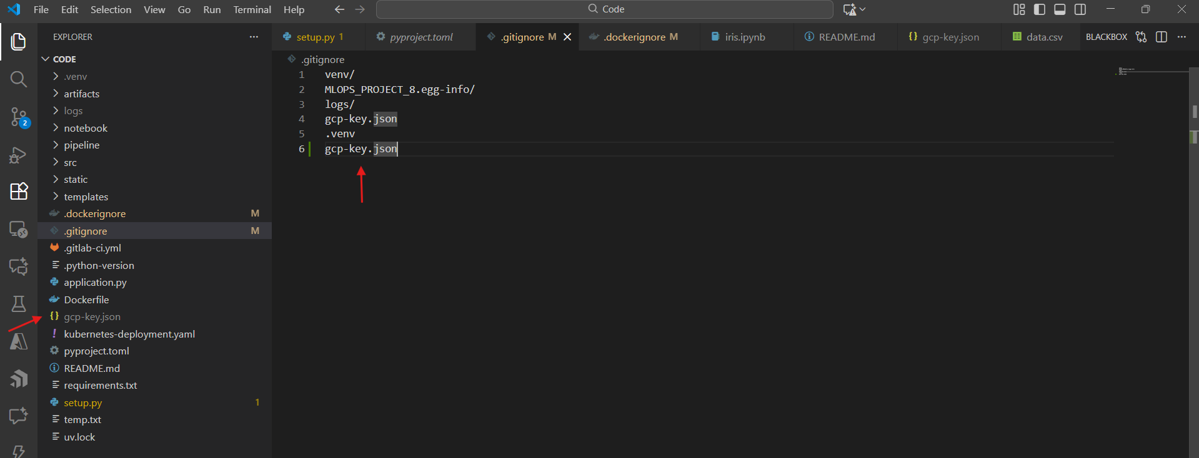
Convert and store in the Base 64 using git bash from Vs code
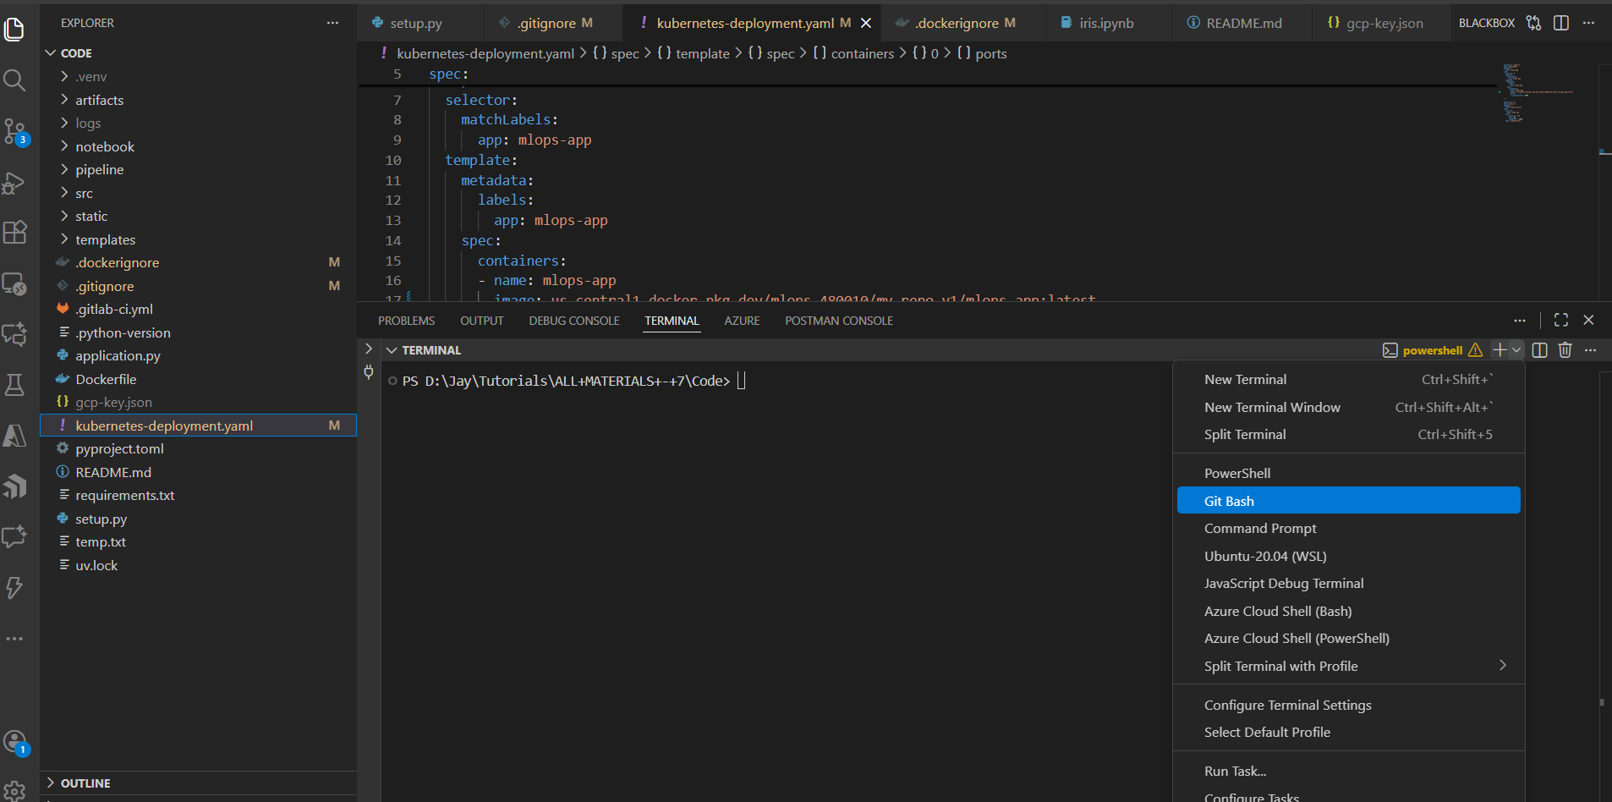

cat gcp-key.json | base64 -w 0

add this variable in the GitLab pipeline variable
copy the key
go to GitLab > setting > CICD
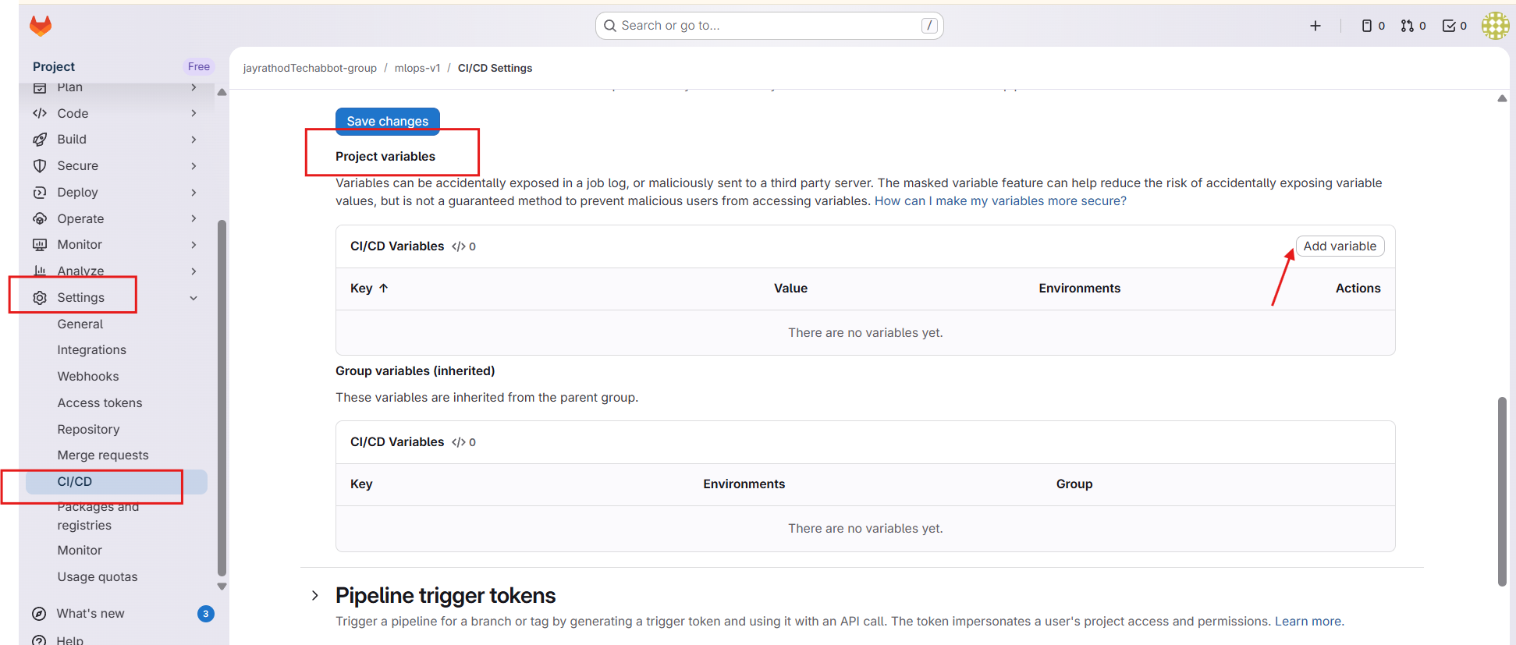
Visibility: visible
Name : GCP_SA_KEY
Key = base64

Create a k8s cluster
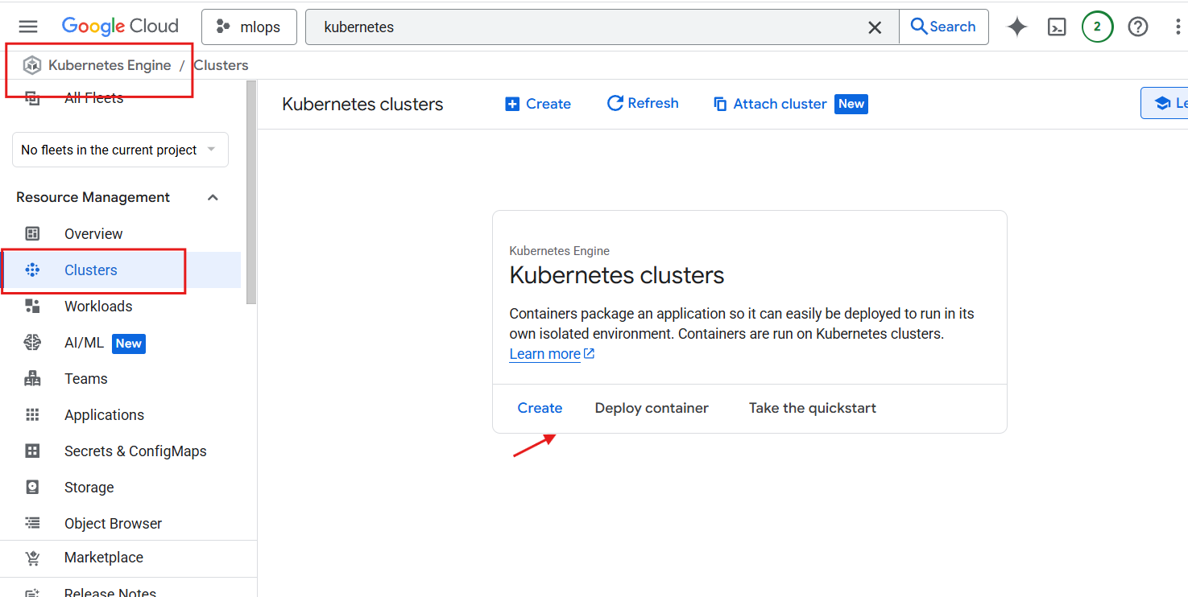
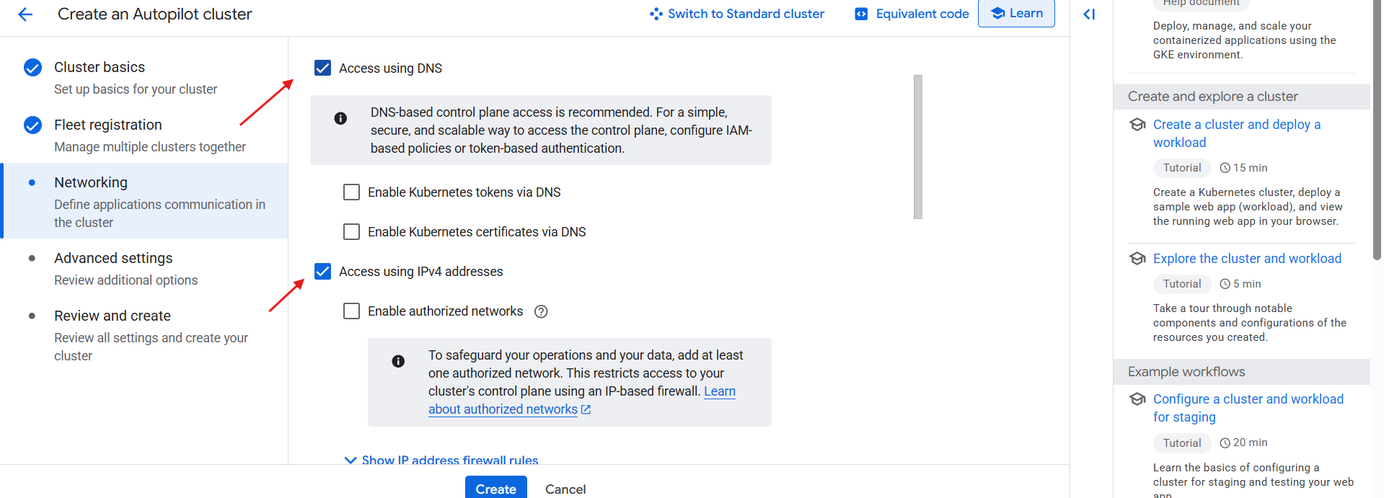

Verify before creating
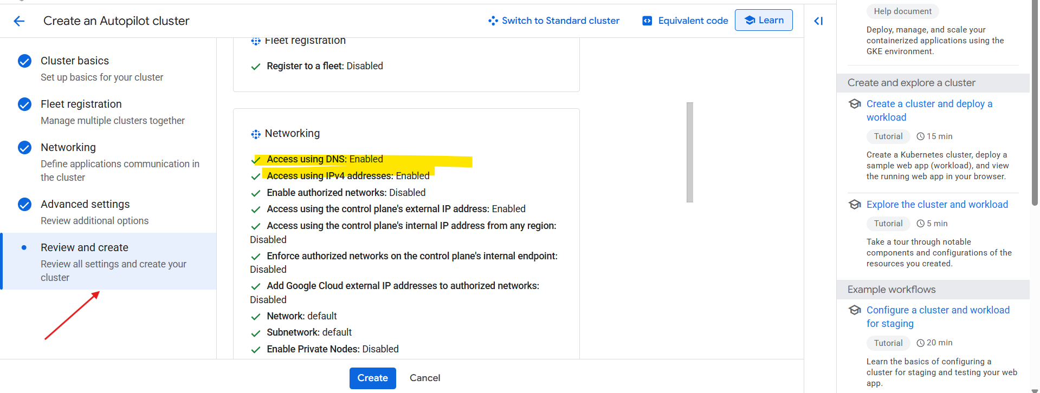

Add registry url in the deployment config of k8s
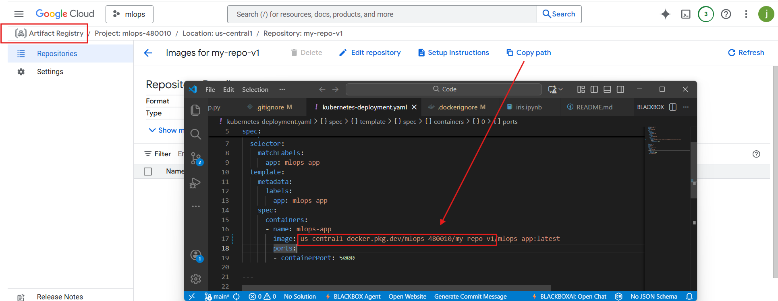

Format = < > / image_name:version

Write CICD pipeline
Create a file name .gitlab-ci.yml

Project id
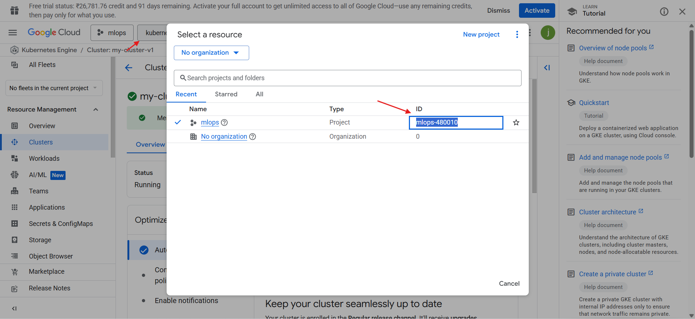
Cluster & region
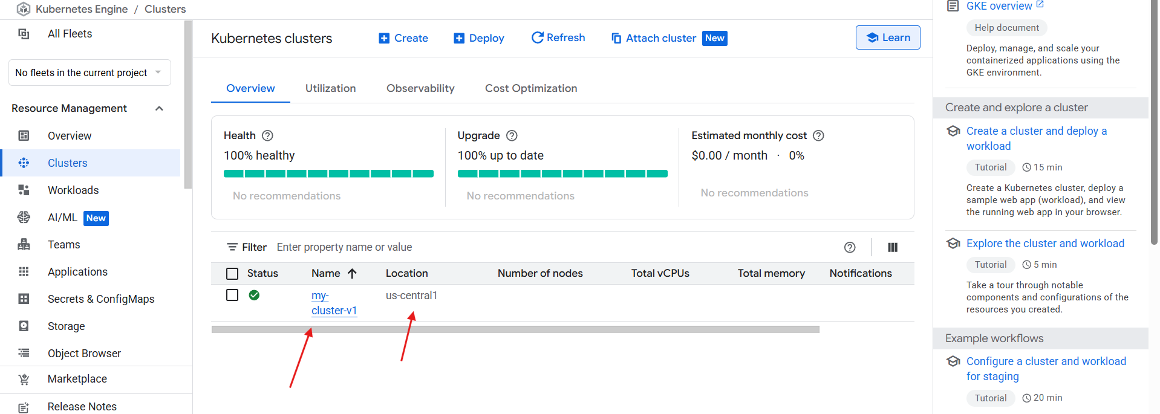
For registry : copy and put path upto .dev
us-central1-docker.pkg.dev
and last one will be repo name
my-repo-v1
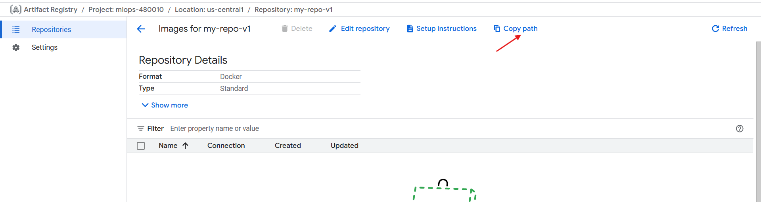

variables:
PROJECT_ID: "mlops-480010"
REGION: "us-central1"
REPO: "my-repo-v1"
REGISTRY: "us-central1-docker.pkg.dev"
CLUSTER: "my-cluster-v1"

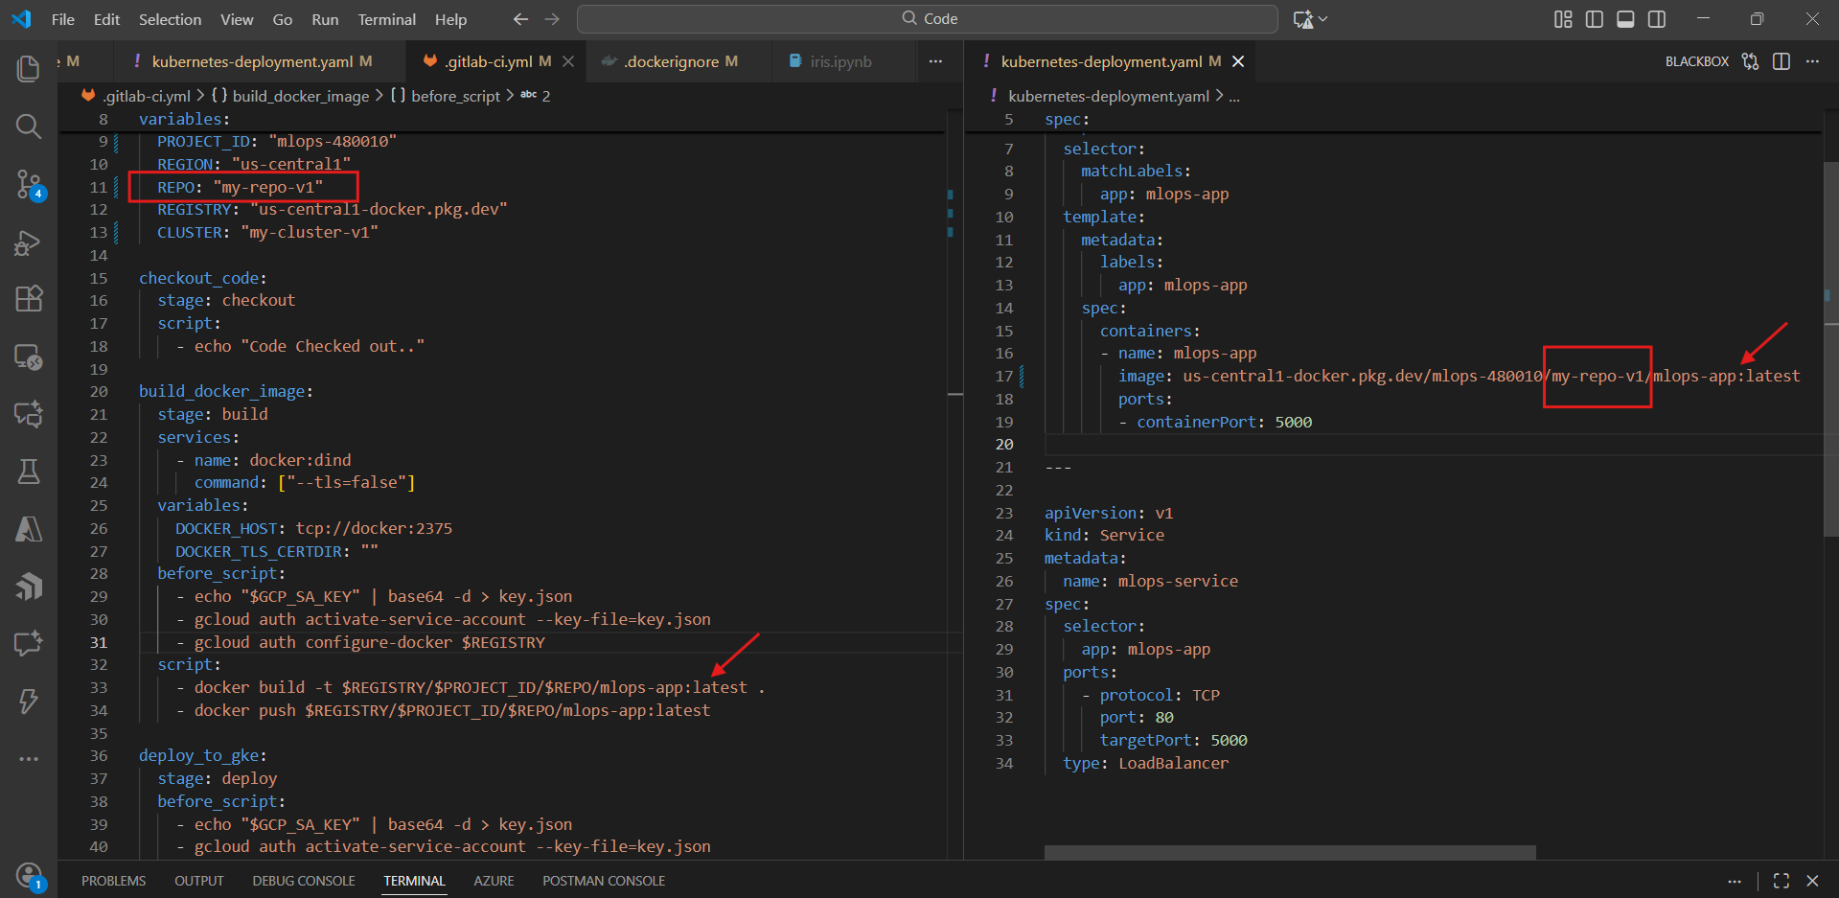

For verification
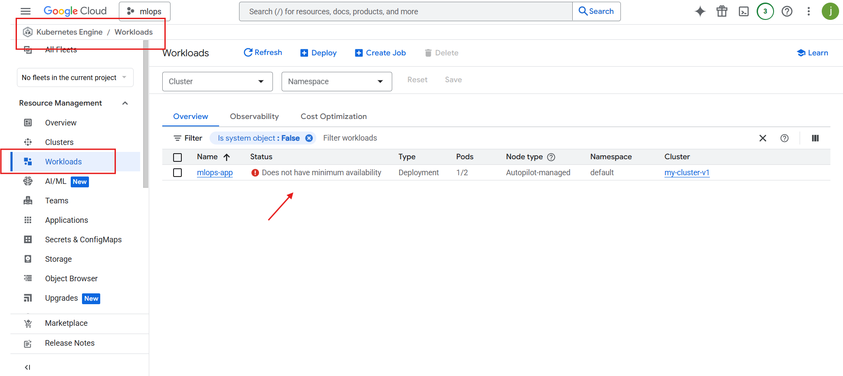
Wait for 5-10 min

Wait for some more time for end point
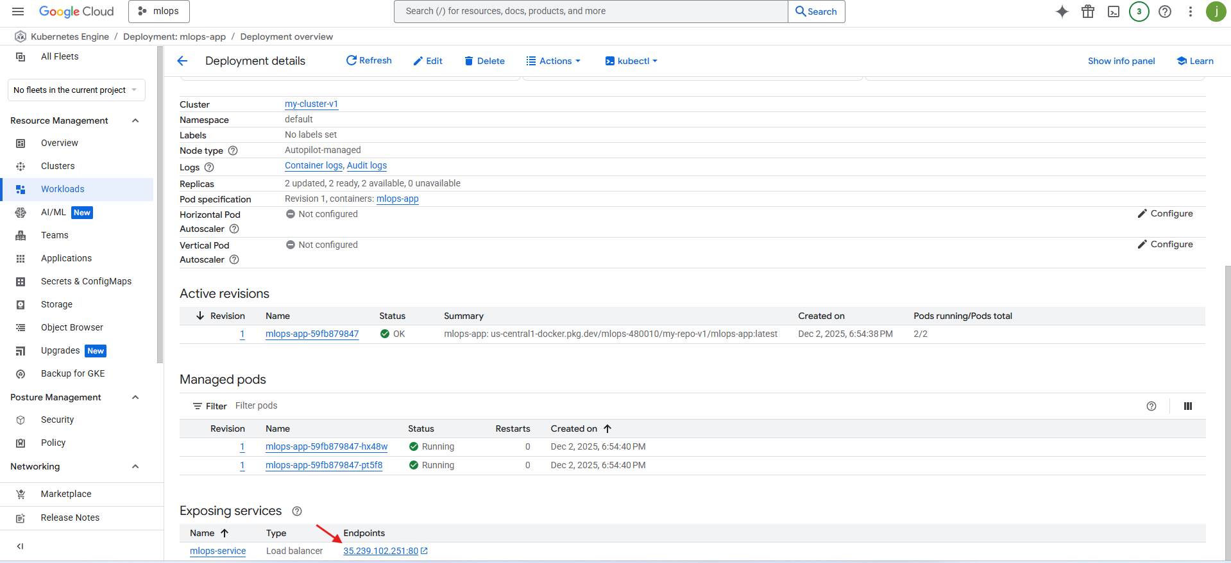
Working perfectly fine.

If update html not reflected
1. Ensure Docker builds a fresh image
# Dockerfile example
FROM python:3.11-slim
WORKDIR /app

COPY requirements.txt /app/
RUN pip install --no-cache-dir -r requirements.txt

# Copy application last (so changes always trigger rebuild)
COPY . /app

EXPOSE 5000
ENV FLASK_APP=application.py
CMD ["python", "application.py"]

Copy application after dependencies to ensure HTML/JS changes trigger rebuild.

2. Use a unique image tag for each deployment
Instead of :latest, use commit SHA:
# GitLab CI example
variables:
IMAGE_TAG: $CI_COMMIT_SHA

script:
- docker build -t $REGISTRY/$PROJECT/$REPO:$IMAGE_TAG .
- docker push $REGISTRY/$PROJECT/$REPO:$IMAGE_TAG
- kubectl set image deployment/my-app my-app=$REGISTRY/$PROJECT/$REPO:$IMAGE_TAG

image: google/cloud-sdk:latest

stages:
- checkout
- build
- deploy

variables:
PROJECT_ID: "mlops-480010"
REGION: "us-central1"
REPO: "my-repo-v1"
REGISTRY: "us-central1-docker.pkg.dev"
CLUSTER: "my-cluster-v1"

# checkout_code:
# stage: checkout
# script:
# - echo "Code Checked out.."

build_docker_image:
image: docker:26-cli
stage: build

services:
- name: docker:26-dind
command: ["--tls=false"]

variables:
DOCKER_HOST: "tcp://docker:2375"
DOCKER_TLS_CERTDIR: ""

before_script:
- apk add --no-cache curl bash python3 tar

# Download & install gcloud
- curl -L https://dl.google.com/dl/cloudsdk/channels/rapid/downloads/google-cloud-cli-548.0.0-linux-x86_64.tar.gz -o gcloud.tar.gz
- tar -xf gcloud.tar.gz
- ./google-cloud-sdk/install.sh --quiet

# Add gcloud to PATH
- export PATH="$PATH:/builds/$CI_PROJECT_PATH/google-cloud-sdk/bin"

# Auth
- echo "$GCP_SA_KEY" | base64 -d > key.json
- gcloud auth activate-service-account --key-file=key.json
- gcloud auth configure-docker "$REGISTRY" --quiet

script:
- docker --version
- gcloud --version

- docker build -t $REGISTRY/$PROJECT_ID/$REPO/mlops-app:latest .
- docker push $REGISTRY/$PROJECT_ID/$REPO/mlops-app:latest

deploy_to_gke:
stage: deploy
before_script:
- echo "$GCP_SA_KEY" | base64 -d > key.json
- gcloud auth activate-service-account --key-file=key.json
- gcloud auth configure-docker $REGISTRY
script:
- gcloud container clusters get-credentials $CLUSTER --region $REGION --project $PROJECT_ID
- kubectl apply -f kubernetes-deployment.yaml

